EXPERIMENT NO: 6 DATE: / / 20

AIM: To study and perform Zener diode as voltage regulator.

APPARATUS: Zener diode as voltage regulator kit, connecting wires, Digital multimeter.

THEORY :

Zener diode will continue to regulate the voltage until the diodes current falls below the minimum I_{Z(min)} value in the reverse breakdown region. It permits current to flow in the forward direction as normal, but will also allow it to flow in the reverse direction when the voltage is above a certain value - the breakdown voltage known as the Zener voltage. The Zener diode specially made to have a reverse voltage breakdown at a specific voltage. Its characteristics are otherwise very similar to common diodes. The purpose of a voltage regulator is to maintain a constant voltage across a load regardless of variations in the applied input voltage and variations in the load current. The resistor is selected so that when the input voltage is at V_{IN (min)} and the load current is at I_{L(max)} that the current through the Zener diode is at least I_{z(min)}. Then for all other combinations of input voltage and load current the Zener diode conducts the excess current thus maintaining a constant voltage across the load.

CIRCUIT DIAGRAMS:

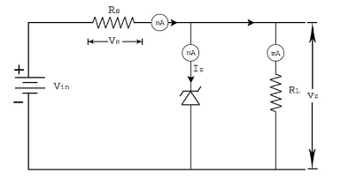
Fig:7.1 zener diode as voltage regulator

PROCEDURE:

- Wire up the circuit shown in figure 7.1
- Record the voltage across the Zener diode (V) and current (I) through it as a function of input voltage. Find Zener Voltage
- Keep the load resistance R_{L} constant. Vary the input voltage in short steps and record the voltage across the Zener diode and current flowing through the R_{L}.
- Repeat the above step for various Vin values.

OBSERVATION TABLE:

SR NO | Supply Voltage | Voltage Across Zener Diode  Vz(V) | Current through R_{L}  I (mA)

CONCLUSION:

EXPERIMENT NO: 7 DATE: / /20

AIM: To study and perform half wave rectifiers.

APPARATUS: Bread board, power supply, PN diode, resisters, connecting wires, CRO

THEORY:
A rectifier is a circuit which converts the Alternating Current (AC) input into a Direct Current(DC) output . The input supply may be either a single-phase or a multi-phase supply with the simplest of all the rectifier circuits being that of the Half Wave Rectifier. The diode in a half wave rectifier circuit passes just one half of each complete sine wave of the AC supply in order to convert it into a DC supply. Then this type of circuit is called a “half-wave” rectifier because it passes only half of the incoming AC power supply.

HALF WAVE RECTIFIER CIRCUIT:

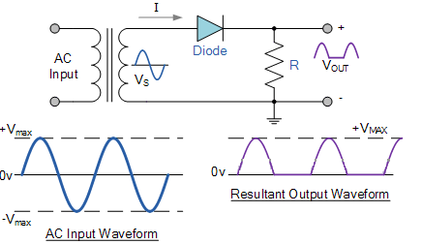

OUTPUT Waveforms:

CONCLUSION:

EXPERIMENT NO: 8 DATE: / /20

AIM: To study and perform Full wave rectifiers.

APPARATUS: Bread board, power supply, PN diode, resisters, connecting wires, CRO

THEORY:
The full wave rectifier circuit consists of two diodes connected to a single load resistance (R_{L}) with each diode taking it in turn to supply current to the load. When point A of the transformer is positive with respect to point C, diode D₁ conducts in the forward direction as indicated by the arrows.
When point B is positive (in the negative half of the cycle) with respect to point C, diode D₂ conducts in the forward direction and the current flowing through resistor R is in the same direction for both half-cycles. As the output voltage across the resistor R is the phasor sum of the two waveforms combined, this type of full wave rectifier circuit is also known as a “bi-phase” circuit.

FULL WAVE RECTIFIER CIRCUIT:

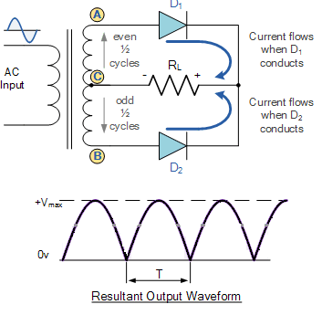

OUTPUT Waveforms:

CONCLUSION:

EXPERIMENT NO: 9 DATE: / /20

AIM: To study the input and output characteristics of a transistor in Common Base Configuration.

APPARATUS: Transistor, Resistors, Bread Board, Multi meter, Connecting wires and Power Supply

THEORY:

Bipolar Junction Transistor (BJT) is a three terminal (emitter, base, collector) semiconductor device. There are two types of BJTs, namely NPN and PNP. It consists of two PN junctions, namely emitter junction and collector junction. The basic circuit diagram for studying input characteristics is shown in the circuit diagram. The input is applied between emitter and base, the output is taken between collector and base. Here base of the transistor is common to both input and output and hence the name is Common Base Configuration. Input characteristics are obtained between the input current and input voltage at constant output voltage. It is plotted between VEE and IE at constant VCB in CB configuration. Output characteristics are obtained between the output voltage and output current at constant input current. It is plotted between VCB and IC at constant IE in CB configuration.

PROCEDURE:

Input Characteristics:
- Connect the circuit as shown in the circuit diagram.
- Keep output voltage VCB = 0V by varying VCC.
- Varying VEE gradually, note down emitter current IE and emitter-base voltage(VEE).
- Step size is not fixed because of nonlinear curve. Initially vary VEE in steps of 0.1 V. Once the current starts increasing vary VEE in steps of 1V up to 30V.
- Repeat above procedure (step 3) for VCB = 5V.
Output Characteristics:
- Connect the circuit as shown in the circuit diagram.
- Keep emitter current IE = 0mA by varying VEE.
- Varying VCC gradually in steps of 1V up to 30V and note down collector current IC and collector-base voltage (VCB).
- Repeat above procedure (step 3) for IE = 5mA.

OBSERVATION TABLE:
Input Characteristics
V_{EE} (Volts) | V_{CB} = |  | V_{CB} =
V_{EE} (Volts) | V_{EB} (Volts) | I_{E} (mA) | V_{EB} (Volts) | I_{E} (mA)

Output Characteristics
V_{CC} (Volts) | I_{E} = |  | I_{E} =
V_{CC} (Volts) | V_{CB} (Volts) | I_{C} (mA) | V_{CB} (Volts) | I_{C} (mA)

CONCLUSION:

EXPERIMENT NO: 10 DATE: / /20

AIM: To perform resonance in series R-L-C circuit.

APPARATUS: kit, function generator, connecting wires, Digital Multimeter.

THEORY:
Resonance condition of an RLC series circuit can be obtained by equating X_{L} and X_{C}, so that the two opposing phasors cancel each other. At resonance, the effects of the inductor and capacitor cancel, so that Z=R, and I_{rms} is a maximum. Resonance is the tendency of a system to oscillate with greater amplitude at some frequencies than at others. Frequencies at which the response amplitude is a relative maximum are known as the system's resonance frequencies. The voltage through an RLC series circuit will be measured as a function of frequency for a fixed applied voltage. The frequency for which the rms voltage attains a maximum value is the resonance frequency. The expected resonance frequency is given by equation,
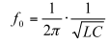

R-l-C SERIES CIRCUIT:
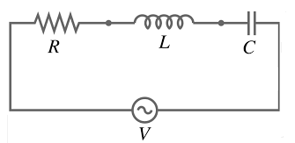
RESONANCE CURVE

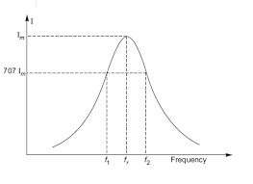

PROCEDURE:

- Wire up the circuit as shown in circuit diagram.
- Connect function generator output at the input of kit.
- Vary the frequency in short steps and record the current flowing through series elements.
- Repeat the above step until reaches to resonant frequency.
- Plot the relevant graph.

OBSERVATION TABLE:

Sr.No | Frequency | Current

CALCULATION:

CONCLUSION:

